**Tim Cross Building**

**Design & Drafting**

**Services**

340 Half Chain Road

Koorainghat NSW 2430

Phone: 02 65536114 / 0429021748

[ttcross1@bigpond.com](mailto:ttcross1@bigpond.com)

ABN: 61155460062

10/12/2024

Statement of Environmental Effects

Proposed Minor Alteration & Change of Use

To Existing Small Shop at 14 Fotheringham St

Disclaimer

While every reasonable effort has been made to ensure that this document is correct at the time of publication. Tim Cross building Design & its Agents, disclaim any & all liability to any person in respect of anything or the consequences of anything done or omitted to be done in reliance upon the whole or any part of this document.

The Proposal

The owner, Steven Becker, wishes to restore & utilise the existing small shop at the front of his property as a Bowen Therapy Treatment room. The shop Has been empty for some time but was previously used as a Hairdressers, & was originally a General Store

Steven will be the sole operator of the small business.

Proposed Business Hours

Monday to Friday 9am to 5pm

Saturday 9am to 1pm

3 to 4 Clients per day

1.5 Hours per session with 30min break between Clients.

Only 1 Client on site at any time.

The Site.

The subject property is legally described as Lot85 DP9740, 14 Fotheringham Street Taree.

Lot Size 1012m2

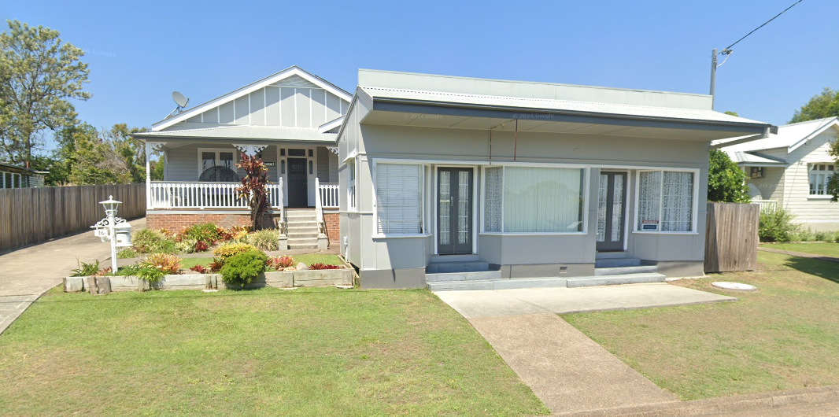

GREATER TAREE LEP

**Zone R1   General Residential**

**1**   **Objectives of zone**

•  To provide for the housing needs of the community.

•  To provide for a variety of housing types and densities.

•  To enable other land uses that provide facilities or services to meet the day to day needs of residents.

**2**   **Permitted without consent**

Home occupations

**3**   **Permitted with consent**

Advertising structures; Attached dwellings; Backpackers’ accommodation; Bed and breakfast accommodation; Boarding houses; Boat launching ramps; Boat sheds; Building identification signs; Cemeteries; Centre-based child care facilities; Community facilities; Dual occupancies; Dwelling houses; Early education and care facilities; Educational establishments; Emergency services facilities; Environmental protection works; Exhibition homes; Exhibition villages; Flood mitigation works; Group homes; Health services facilities; Home businesses; Home industries; Hostels; Hotel or motel accommodation; Information and education facilities; Jetties; Moorings; Multi dwelling housing; Neighbourhood shops; Oyster aquaculture; Places of public worship; Pond-based aquaculture; Recreation areas; Recreation facilities (indoor); Residential flat buildings; Respite day care centres; Restaurants or cafes; Roads; Secondary dwellings; Semi-detached dwellings; Seniors housing; Service stations; Serviced apartments; Sewerage systems; Shop top housing; Take away food and drink premises; Tank-based aquaculture; Veterinary hospitals; Water recreation structures; Water supply systems

Result

**The Proposal meets the objectives of the R1 zone ,**

**The Proposed Treatment Room will provide for the Health & wellbeing of the local community . The proposed works will help maximise the service provided while maintaining the Heritage look & feel of the surrounding neighbourhood.**

GREATER TAREE DCP Assessment

PART I COMMERCIAL REQUIREMENTS

Objectives

o Ensure an appropriate supply, distribution, and mix of retail, commercial and employment floor space across the Local Government Area (LGA);

o Ensure that the retail floor space within the Greater Taree LGA does not undermine the potential of existing and proposed centres within the region;

o Encourage the early investment and delivery of employment generating development and retail uses to serve the population;

o Achieve high quality urban design outcomes which deliver economic, social and environmental benefits to existing and new residents;

o Promote business development which is designed to facilitate an active public domain;

o Ensure business zones in the Greater Taree LGA are supported by adequate and appropriate public infrastructure and amenities

Result

The Proposal meets the objectives of a Commercial Shop Front.

**Function & use**

The proposal provides for the health needs of the local community

**Layout & Design**.

The building has some heritage significance so will be Kept basically in its existing form.

**Built Form & Appearance.**

The building has some heritage significance so will be Kept basically in its existing form.

**Pedestrian Amenity.**

The existing building has good concrete Footpath access & shelter over the entrance door for protection against bad weather. There is very little overshadowing of pedestrian thoroughfares & Pathways.

**Public Domain**

The existing Street scape is well established with concrete pathways bordered by mature lawns & existing Trees

**Carparking.**

The Proposed Bowen therapy practice has only one treatment room & a Waiting room. It is expected that there will be only three to four clients per day with only one client on the premises at any one time. The street is Generally quiet & street side parking is readily available. The owner operator of the business will park in his existing residence at the back of the Therapy rooms.

**HERITAGE STATEMENT**

After having some discussions with Councils Aaron Kelly, it is agreed that the old shop does have some heritage significance. It was built in the early 1950’s & features some inset French doors which where a fairly common feature of the time that is not often seen now. It’s for this reason that the external façade of the building will remain basically unchanged except for the replacement of door & window parts where necessary & new external weatherboard cladding to match the original residence at the rear of the old shop. All internal linings will be replaced & painted.

**COLOUR SCHEMES AND PAINTING**

The building will be repainted in its original colour scheme.

Regards

Tim Cross